**Ideation Phase**

**Define the Problem Statements**

|  |  |
| --- | --- |
| DATE | 19 September 2022 |
| TEAM ID | PNT2022TMID10141 |
| PROJECT TITLE | Smart Waste Management System for Metropolitan Cities |
| MAXIMUM MARK | 2 Marks |

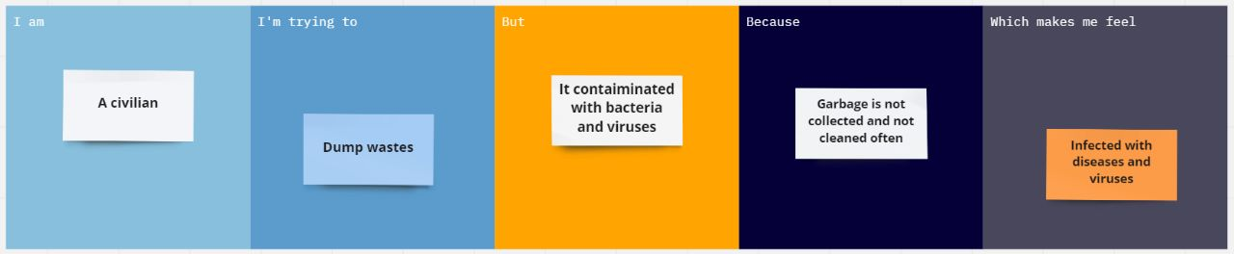

|  |  |
| --- | --- |
| **Problem Statement (PS):** | Waste management involves the regular collection, transportation as well as processing and disposal or recycling and monitoring of different types of waste materials. These services can save your business a considerable amount of money, and can also prevent the environment from being harmed. |
| **I am**  **(CIVILIAN)** | A civilian, who uses trash bins to dump the wastes on regular basis. |
| **I’m trying to** | Dump wastes regularly |
| **But** | Trash bins placed locally is overfilled with garbage and it may be contaminated with bacteria and viruses |
| **Because** | Proper maintenance is not taken care of regularly, and the garbage collector is not aware of the bins that are full and unhygienic. |
| **Which makes me feel** | People infected with disease and virus, foul smell, bad environment and affects ecosystem. |